Multiple-choice section – choose the correct answer

Question 1 [3.1]

What is the expansion of ?

A  B  C  D 

Question 2 [3.1]

Expanded, the expression  is:

A  B  C  D 

Question 3 [3.2]

Fully factorised,  is:

A  B  C  D 

Question 4 [3.4]

The dilation factor of  is:

A  B 2 C 5 D 4

Question 5 [3.4]

The equation of the graph of  is dilated by a factor of 2, shifted 1 unit left and 3 units up is:

A y = 3(x – 2)2 + 1 B y = 2(x – 1)2 + 3 C y = 2(x – 3)2 + 1 D y = 2(x + 1)2 + 1

Question 6 [3.5]

In factorised form,  is:

A  **B**  **C**  **D** 

Question 7 [3.6]

When w2 – 100 is factorised, it is:

A (*w* + 100)(*w* – 1) **B** (*w*2 + 10)(*w*2 – 10) **C** (*w* + 10)(*w* – 10) **D** (*w* – 10)2

Question 8 [3.7]

 simplifies to:

A  B  C  D 

Multiple-choice total marks: __ / 8

Short answer section

Question 9 2 marks [3.2, 3.5]

Use words from the list below to complete the following sentences.

factorising algebraic fractions perfect squares monic

difference of two squares completing the square quadratic trinomial binomial product

(a) ______________ involves taking out the highest common factor of terms.

(b) Expressions containing variables in fraction form are _____________________________.

Question 10 2 marks [3.6]

Explain the term *difference of two squares*. Use an example to help you explain.

Question 11 2 marks [3.1]

Expand and simplify.

Question 12 4 marks [3.1]

(a) Give the expression for the perimeter of the triangle in simplest form.

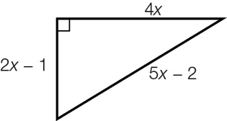

(b) Write the area of the triangle in expanded form.

Question 13 2 marks [3.1]

The length and width of a rectangle is  and respectively. Write the area of the rectangle in expanded form.

Question 14 3 marks [3.2]

Xia wants to factorise the expression 8*wd* + 2*dp* – 4*rd*.

(a) What highest common factor must Xia use?

(b) What factorised expression will she obtain?

Question 15 4 marks [3.2]

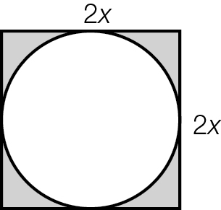

(a) Write an expression for the area of the whole square.

(b) Write an expression for the area of the circle. (Hint: The area of a circle is π*r*2.)

(c) Using your answers for (a) and (b), write an expression for the shaded area.

(d) Factorise your answer to (c).

Question 16 3 marks [3.4]

Explain the transformations required to obtain the graphs of  from 

Question 17 3 marks [3.4]

Use transformations to sketch the graph of y = 2(x – 1)2 + 3.

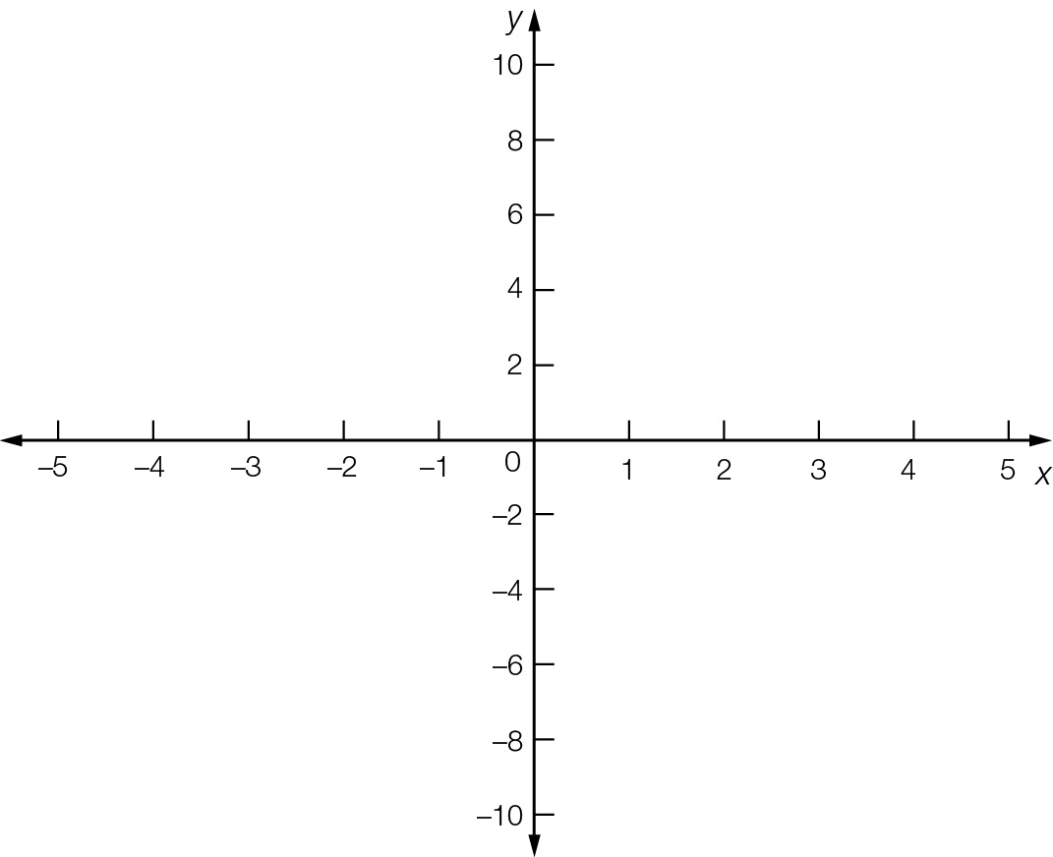

Question 18 3 marks [3.6]

Complete the missing parts of the calculation.

6*a*2*b*2 – 24*w*2

= 6(*a*2*b*2 − __*w*2)

= 6((*__*)2 − (__*w*)2 )

= 6(*ab* − __*w*)(*ab* + __*w*)

Question 19 3 marks [3.7]

By first factorising the numerator, simplify .

Question 20 3 marks [3.7]

Simplify  by writing the expression with a common denominator.

Short answer total:_________/34

Extended answer section

Question 21 5 marks [3.1]

Let a and b be two numbers with 

(a) Express b in terms of a.

(b) Write the product of the two numbers in terms of a.

(c) Expand and simplify the expression in (b).

Question 22 5 marks [3.5, 3.6]

(a) Factorise using the cross method.

(b) Write in the form (___)2.

(c) Hence factorise .

Question 23 6 marks [3.5]

The height h m of a ball above the ground at time t seconds after it has been thrown from a roof is given by .

(a) How high is the ball above the ground when it is first thrown (that is, when t = 0)?

(b) Factorise .

(c) State the time it takes for the ball to reach the ground (that is, what positive value of t makes h = 0?).

Question 24 5 marks [3.1, 3.2]

The diagram shows the floor plan of a room. The lengths are in metres.

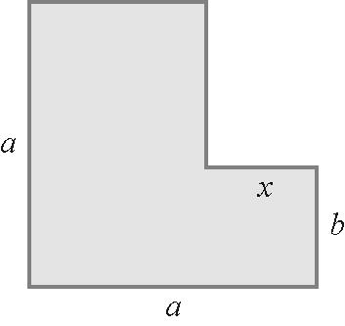

(a) Label each unlabelled side with expressions for their lengths.

(b) Find an expression for the area of the carpet by adding two rectangular areas. Write your answer in expanded form.

(c) Find an expression for the area of the carpet by subtracting the area of C from the area of the large rectangle. Write your answer in expanded form.

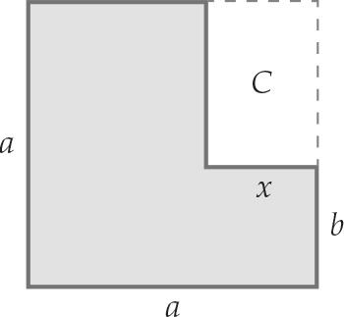

Extended answer total:_________/21

TOTAL test results: ___ / 63